BABEŞ-BOLYAI UNIVERSITY CLUJ-NAPOCA

FACULTY OF MATHEMATICS AND COMPUTER SCIENCE

SPECIALIZATION COMPUTER SCIENCE IN ENGLISH

DIPLOMA THESIS

CHALLENGE BASED CODE TRAINING PLATFORM USING UNITY GAMES

Scientific supervisor: Lect. Ph.D. Arthur Molnar

Author: Sabau Andrei-Mircea

UNIVERSITATEA BABES-BOLYAI CLUJ-NAPOCA

FACULTATEA DE MATEMATICA SI INFORMATICA

SPECIALIZAREA INFORMATICA ENGLEZA

LUCRARE DE LICENTA

PERFECTIONAREA NIVELULUI DE PROGRAMARE PRIN INTERMEDIUL UNEI PLATFORME DE TIP JOC CONSTRUITA FOLOSIND UNITY

Conducator stiintific: Lect. Ph.D. Arthur Molnar

Abslovent: Sabau Andrei-Mircea

**Abstract**

This thesis is about an alternative way of improving coding skills by using a coding platform designed using Unity3D engine. The main purpose of the platform is to demonstrate its reliability among the computer science students. The main factor that sits behind the improvement of any type of skill is the lack of interest. Therefore, we sought to solve this by creating a platform that would get this factor out of the equation.

In the recent years, education has reached a totally new level all of the learning techniques diversifying at the maximum. Even so, some of the techniques are not interested enough to be used on daily basis. Therefore, we sought to solve this by using gaming as an education tool and creating a platform designed for beginner coders. The platform allows the users to practice and improve their coding skills by creating their own strategy, a bot, and sending it into an arena like game receiving live results of the strategy.

To demonstrate the capabilities of the project, a bomber man style game was created to be used by the platform. The platform was designed to support two types of challenges: learning and improving matches, played versus AIs and competition matches, designed for players that are good enough to test their coding knowledge by competing with other players.

This first chapter discusses about the papers domain. The second chapter provides theoretical background and introduces the necessary concepts for the understanding of the paper. The third describes our approach to combine all the technologies mentioned in the previous chapters to create the challenge based code training platform. The fourth chapter contain discussions on the challenges encountered during the development process of the application and the results. The last chapter presents future work ideas.

This work is the result of my own activity. I have neither given nor received unauthorized assistance on this work.

Sabau Andrei-Mircea

**Contents**

1. **Gaming in Education** 6

1.1 **What is a game?** 6

1.2 **Game Based Learning – Benefits** 6

1.3 **Game Based Learning – Challenges** 6

2. **Technical Background** 7

2.1 **Networking and Data Communication** 7

2.1.1 Types of Computer Networks 8

2.1.2 Addresses 9

2.1.3 Client and Server 9

2.1.4 Sockets 11

2.2  **Unity Game Development** 13

2.2.1 What is Unity? 13

2.2.2 Unity Editor Window 14

2.2.3 Unity Game Objects 15

3. **Software and Implementation** 16

3.1 **Software used** 16

3.2 **Architecture** 16

3.3 **Program Flow** 17

3.4 **Python server** 19

3.4.1 New Clients Manager 19

3.4.2 Connection Handler 20

3.4.3 Game Manager 21

3.4.4 Server Build 22

3.5  **Python client** 22

3.5.1 Connecting to the server 22

3.5.2 Client validation by the server 23

3.5.3 Sending and receiving data 23

3.5.4 Player Class 23

3.6 **Creating the game** 24

3.6.1 Level design 25

3.6.2 Map generation 26

3.6.3 Network Manager 28

3.6.4 Initial Game Data 29

3.6.5 Game Manager 29

3.6.6 Map Debugger 32

3.7 **Platform Strong Points** 33

4. **Results and discussions** 364

5. **Conclusion** 355

6. **Future work** 356

**Bibliography** 377

**List of figures**

2.1 Network example.................................................................................................................7

2.1.1 LAN MAN and WAN.......................................................................................................9

2.1.3 Server request in a web browser......................................................................................10

2.1.4.1 TCP Scheme.................................................................................................................11

2.1.4.2 UDP Scheme.................................................................................................................12

2.2.1 Unity logo........................................................................................................................13

2.2.2 Unity Editor Window......................................................................................................14

2.2.3 Unity Standard GameObjects.........................................................................................15

3.2.1 The architecture of the system........................................................................................16

3.3.1 Program flow...................................................................................................................18

3.4 Python Server console log..................................................................................................19

3.4.1 New clients Manager Method in Python.........................................................................20

3.4.4 Server build files..............................................................................................................22

3.5.2 Python Client console log................................................................................................23

3.5.4 Python Player Class........................................................................................................24

3.6 Graveyard Friends Game...................................................................................................25

3.6.1.1 Unity Asset containing the 3D Models.........................................................................25

3.6.1.2 Unity Particles System.................................................................................................26

3.6.2 Map Generation Code in Python....................................................................................27

3.6.5.1 Map before preparation................................................................................................30

3.6.5.2 Map after preparation..................................................................................................30

3.6.5 Single player parameters panel........................................................................................31

3.6.6 Map debugger..................................................................................................................32

**Introduction**

This thesis is about an approach to improve and challenge the coding skills by using a gaming environment. We will study the process of developing of such system and its feasibility.

In the recent years, the education improved a lot. Humans switched the lever of learning from books in favor of learning from sources like: internet, audio books and online courses. Furthermore, people tend to opt more for the rewarded based systems, they are tired of learning something if they do not find it interesting enough or if they do not get an immediate satisfaction while doing it. There are plenty examples of students that simply rush their studies in order to get rid of them because the courses are not interesting enough to catch their attention. So are the programmers, if they do not like what they are coding, the will never bother coding it.

This thesis aim is to combine the utility with the pleasure, learning to code while playing games. This is achieved through a Unity application that allows the user to play a game by coding the strategy. The code written by the player gets executed and the response is converted into visual output.

The game we have created to demonstrate the capabilities of this system is a bomber man style game simulation. The purpose is to collect items and to eliminate other enemies, both things being done by selecting actions from a list of possible moves.

The technologies that have been used are the following: Python, for implementing the Client and Server side, Unity C# for implementing and designing the game and the environment, Sockets for establishing the connection between the server and the game. Moreover, the game also uses an external asset for the 3D game models.

The thesis is structured in five chapters as follows.

Chapter 1, **Gaming in Education**, defines the domain of our paper. It offers a definition for the game along with benefits and drawbacks of using gaming as a tool in education.

Chapter 2, **Technical Background,** introduces the main layers of the thesis, describing the concepts behind data sharing inside a network and the game development using Unity3D framework. After going through the advantages and disadvantages of using a network and understanding a client-server relationship, we start to split the sockets into two categories, TCP and UDP, and see what are the benefits of each one to decide which of those is the most suitable for our project.

Then, we introduce the engine used to create the platform. This section includes a detailed description of the Unity3D game development framework, featuring the main reasons of using this engine. The section also contains an introduction to the Unity3D editor window, presenting the main parts of the program and the list of engine primitives.

Chapter 3, **Software and Implementation,** provides the step by step process of creating our challenge based code training platform. Here we are describing the architecture of the system. This section contains the program flow and all its components. The main components of the system are: Python Server, which is the brain of the system, Python Client which represents the strategy that will get coded by the user and the Unity Client which is the visual output of the platform, all the processed data being rendered by this client.

Chapter 4, **Results and** **Discussions,** presents the obtained results andputs forward some of the challenges that came up in the journey of developing all the three components and wiring them together.

Finally, there is the conclusion and future work. This chapter emphasizes the main points of the paper, while also providing the conclusion of this study. Furthermore, we also provide some ideas considered as a future work.

**Chapter 1**

# Gaming in Education

## 1.1 What is a game?

A defined set of rules that a number of participants follow to play, form a game. A game can be used as a tool to help traditional teaching methods to increase the learning experience of the new learners. This also develops other skills such as: problem solving, critical thinking, adaptation and creativity. Learning should be an easy process where students accomplish the information and the knowledge is built step by step and not forced like in case of memorization [24].

## ****1.2 Game Based Learning – Benefits****

* Games usually build an emotional connection to learning and subject matter.
* Can be used to help users solve problems more effectively and quickly [23]
* It raises the level of user engagement
* A little competition may increase the motivation
* Reward based system of the games makes students feel they made a progress.
* Accept the fact that failure is an indication that more skill and devotement is needed
* Through discrete steps, lead to a major goal, students can see the interrelationship of tactics and strategy [23].
* Increase the confidence level.

## 1.3 Game Based Learning – Challenges

* A lot of time might be needed in order to supervise the students, teach them the rules of the game and provide them a feedback.
* Games take time to learn and design properly.
* Other technical support might be necessary, additional resources and costs [23]

**Chapter 2**

# Technical Background

In this chapter we are taking a look at the concepts and technologies we will be referencing throughout the paper. Section 2.1 gives a detailed overview of what networking means and the how the data is transferred between machines that share the same network. The following part, Section 2.2 will be an introduction to the game development industry using Unity3D. This section points out the reasons why this framework became so popular and which are its strong points, followed by a short detailing of Unity3D user interface and functions.

## 2.1 Networking and Data Communication

A computer network consists of a collection of computers, printers and other equipment that is connected together so that they can communicate with each other [1]. A network is used in order to share the resources and the information. [2.1]

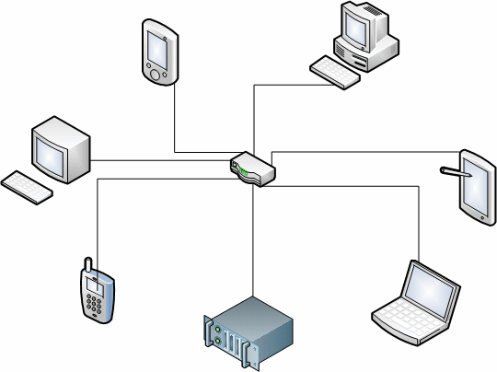

Figure 2.1 Network example.

This network can expand, other computers may join and add their resources to those being already shared. The notion of “data communication” refers to the share of data between computers that can either be inside or outside of a specific network. The connection between computers is realized using the communication cable or the Wi-Fi. The Internet is the best known computer network. In computer networks, the data is send in packets. A data packet does not always contain only the data to be sent, it may also have headers that carry certain types of metadata [2]. Here are some advantages and disadvantages of using computer networks [3]:

**Advantages**

* Easily share of data between computers inside the same network.
* The facilities of the network can be accessed only by authorized users.

**Disadvantages**

* Data and information may be stolen by computer hackers if the security of network is not reliable. Once entered in a network, a hacker can easily get to each computer in the network [3].
* If any computer in a network gets affected by computer virus, there is high chance of spreading computer viruses on the other computer creating a chain reaction, this leading to a corrupted network [3].
* Computers depend on the server for resources and these may be limited.

### 2.1.1 Types of Computer Networks

The devices that transmit or receive data are called “nodes”. There are three main types of networks [4] [2.1.1]:

1. Local Area Network or LAN. This represents a small network. A computer network available only to the class of students can be called a LAN.

2. Wide Area Network or WAN. These networks cover a larger area. For the users inside LAN to be able to communicate with computer in other regions, a WAN is required. The most common WAN is the internet.

3. Metropolitan Area Network or MAN. This size of this particular network is somewhere between LAN and WAN.

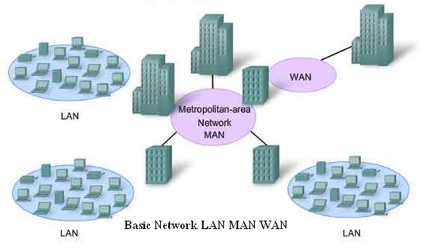

Figure 2.1.1 LAN MAN and WAN

### 2.1.2 Addresses

A network address is used to uniquely distinguish a network node or device over a specific network. It is a combination of numbers or letters that is assigned to any device that request access to or is part of any network. A network address is very important because it works like a key that facilitates the identification and the reach of a network node or device over a network. Each computer inside a network uses a network address to identify, locate and address to other computers [5].

### 2.1.3 Client and Server

The client-server relationship occurs between two computer programs in which the program labeled as client, makes a service request to another program, labeled as server, which fulfills the request.

The client server idea may be used within the same computer but, it is more effective when used within a network [9]. In a network, the client-server model provides a convenient way to interconnect programs that are distributed efficiently across different locations [25]. The central idea of network computing is represented by the client-server model.

We might consider a client, a web browser that requests services from a web server to another computer over the Internet [2.1.3]. Similarly, the computer with TCP/IP installed allows users to request files from File Transfer Protocol servers, as a client, in other computers over the Internet.

Other program relationship models may be: [master/slave](http://searchnetworking.techtarget.com/definition/master-slave), one program coordinating the others, and [peer-to-peer](http://searchnetworking.techtarget.com/definition/peer-to-peer), where any of the two programs being able to start the transaction [9].

Web Server Web Browser Client

Page request

www.google.com/images

Data

Returned page

Figure 2.1.3 Server request in a web browser

**2.1.3.1 Client-Server Applications**

This model is distinguished between applications and devices. A client inside a network makes request to the server by sending different types of messages and the server responds to its request by returning different kinds of results. A server can support a numerous list of clients, and two or more servers can be linked together for a better handling of all the increased requests from the clients, spreading the tasks.

An example of famous applications that follow the client-server model can be: email, FTP, and Web services. Each of these applications contains a user interface followed by a client application that allows its users to connect to the server. When referring to FTP, the users enter an IP address or just a computer name into the program interface to set up a connection to the server [9].

### 2.1.4 Sockets

The communication between two different processes that are on the same or on different machines is ensured by the sockets. It represents a way to talk to other computers using standard Unix file descriptors. In Unix, every I/O action is done by writing or reading a file descriptor. An integer associated with an open file represents a file descriptor and it can be a network connection, a terminal, a text file or something else [7]. The most common type of socket applications are client-server applications, one side acts as the server and waits for connections from clients [22].

**2.1.4.1 Transmission Control Protocol (TCP)**

Using connections between clients and servers, TCP provides a connection oriented service. This kind of transmission protocol provides reliability. Each time a TCP client sends data to the server, it requires a feedback in return. If that feedback is not received, TCP starts to retransmit the data and this time waits longer for a response [8] [2.1.4.1].

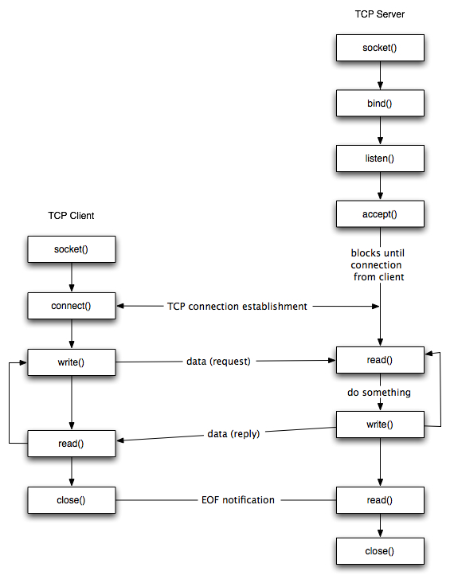

Figure 2.1.4.1 TCP Scheme

**2.1.4.2 User Datagram Protocol (UDP)**

UDP represents a much simpler transport-layer protocol. The application sends a message to an UDP socket, which gets packed into a UDP datagram, which is then packed into an IP datagram, which is sent to the destination. By using User Datagram Protocol there is no guaranteethat the message will reach the destination as expected, meaning that the order of the datagrams may not be preserved across the network or that datagrams may arrive more than once. The reliability is the main problem: if a datagram reaches its final destination but the checksum detects an error, or if the datagram is dropped in the network, it is not automatically retransmitted. The main characteristic of an UDP datagram is the length. The length of a datagram is passed to the receiving application along with the data. Because of the fact that there is no connection established between the client and the server, we say that UDP represents a connection-less service [8].

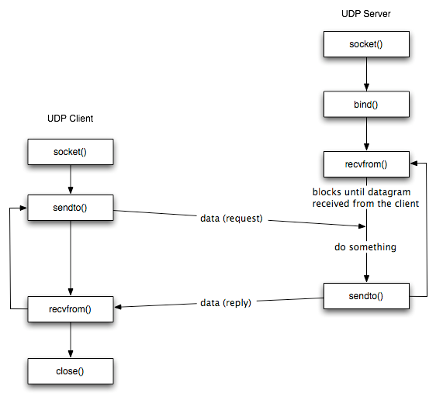

Figure 2.1.4.2 UDP Scheme

## 2.2 Unity Game Development

### 2.2.1 What is Unity?

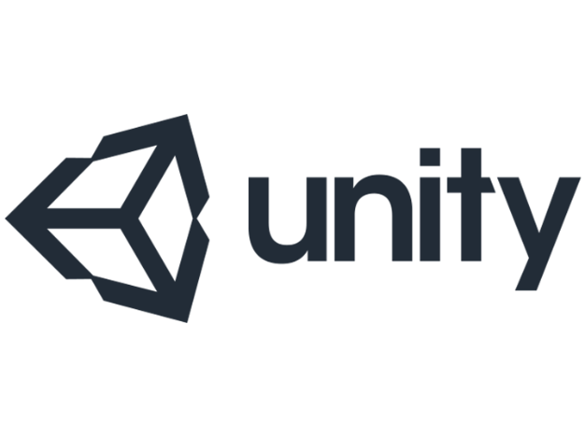

Figure 2.2.1 Unity logo.

Unity 3D [2.2.1] is a game development framework for building 2D and 3D games. The applications are developed once, then, the user have the possibility to deploy its project on different platforms. This framework offers a lot of solutions, features and a stunning architectural visualization. It is an easy to use platform that offers a lot of support for building and deploying. A lot of games have been developed using Unity3D, such as Escape from Tarkov (FPS), Monument Valley (Puzzler), and This War of Mine (Strategy / Survival), the gaming experience being amazing. This engine gathers more and more audience due to its versatility and flexibility, independent developers and gaming studious using it on a daily basis.

Benefits [6]:

* Unity3D represents a framework which is easy to operate with.
* The structure of animation and rendering is highly flexible turning each animation into an amazing game experience.
* It supports cross platforms as well as various devices.
* Scripts can be easily written in JavaScript or C#.
* Unity3D is the preferred game engine for developing multiplayer games, offering a lot of support and documentation for these kind of games.
* Unity3D offers Windows and Mac OS X compatibility
* The drag and drop interface is user-friendly and it saves a lot of time and it is easy to use.
* A project may be exported on more than 12 platforms.

### 2.2.2 Unity Editor Window

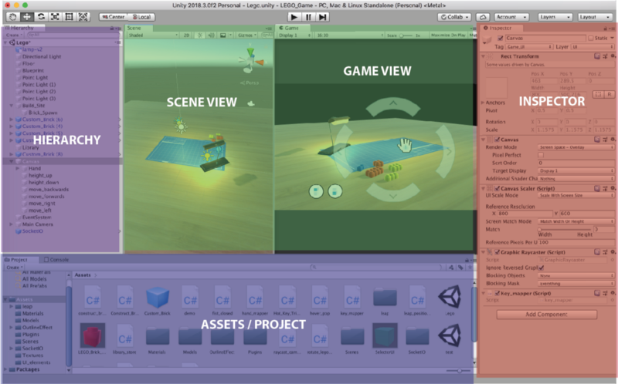

Figure 2.2.2 Unity Editor Window

Hierarchy: The hierarchy contains all the objects that will be used in the current scene. The objects can be easily structured.

Inspector: This windows contains all the information about a selected GameObject. The inspector window allows the user to see each property of the object, to add or remove properties, to modify the current ones and to attach scripts.

Game View: Previews the game point of view, allowing the user to see the final look of the scene.

Scene View: This window represents a scene view, allowing the user to select and modify each object inside the scene. The objects might get their position, rotation or scale modified.

Assets / Project: This represents the resources window. It might contain, scripts, materials, objects, images, shaders and many more.

### 2.2.3 Unity Game Objects

GameObjects are the main type of objects that Unity3D offers. Each thing that is placed inside a scene is wrapped in a game object. This represents a base class that has a lot of properties. The GameObject tab contains a various range of already defined GameObjects [2.2.3] like:

* 3D Objects: Cubes, Capsules, Spheres
* 2D Objects: Sprites, Tilemaps
* Effects: Particle Systems, Lines, Trails
* Light: Point Light, Directional Light, Spot Light

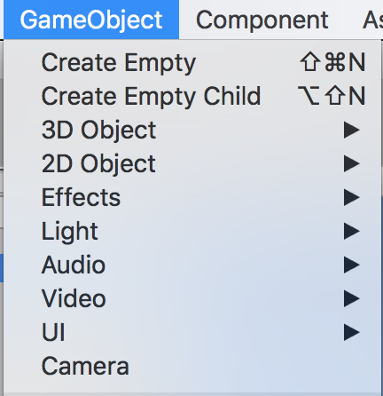

Figure 2.2.3 Unity Standard GameObjects

**Chapter 3**

# Software and Implementation

## 3.1 Software used

This thesis was made using the following technologies: Python 2.7 [15], for writing the client and the server, Unity C# [13], to develop and render the game, TCP Sockets for sending and receiving information and a 3D Asset for the models [14].

## 3.2 Architecture

The architecture of the system is the following [3.2.1]:

Python Client 1

Unity Client 1

Python Client 2

Unity Client 2

Python Client 3

Unity Client 3





Figure 3.2.1 The architecture of the system

Each user will have a corresponding Unity Client which represents the visual representation of the data, this, being the game and a Python Client which is the code part that will be executed in order to provide data for the game, this may be seen also as the game strategy.

We are going create a python server that will manage the new connections and using TCP communication protocol, the server will be able to transfer data fast and safe between Unity game and Python Client.

The server acts like a lobby and in order to connect, a user has to open a Unity Game instance and provide the server address and port. If all Unity Clients that are connected are ready to play, the server will automatically switch to the next state where it waits for each user to connect with the Python Client. At this point, everything is ready and the game can start. The server will continuously send and receive data over the TCP sockets until the game is over.

## 3.3 Program Flow

The user starts by executing the Unity Client. In the Unity Client the user chooses one either to play single player (against a hardcoded AI) or multiplayer (against real players in LAN or Internet).

If single player is chosen, Unity Client will create a local unity server which will handle the input from the Python Client. The game on the single player is customizable, meaning that the user is free to choose the number of AIs and the map generation parameters.

If the multiplayer is chosen, Unity Client will create a new process of Python Server which will manage the clients. Now, the Unity Clients will be able to connect to the server using the IP and PORT of the server. After the server is filled up with Unity Clients or all the Unity Clients press the ready button, each Unity Client will get a token which is going to be used by the Python Client to connect to the Python Server. The server will then wait for all the Python Clients then start generating a random map on which users are going to play. The Python Server will then ensure the flow of the data [3.3.1] unity client -> python server -> python client and backwards, each round. In case of any problem with the player or the data received, the player will be disconnected from the game and the game will continue.

Render

Render

Render

Render

Process Data

Process Data

Process Data

Process Data

Unity Client 1

Unity Client 2

Unity Client 3

Unity Client 4

Handle New Connections

Thread

Handle Disconnected Players

Server

Process Data

Manage Game

Python Client 4

Python Client 3

Python Client 2

Python Client 1

Process Input

Process Input

Process Input

Process Input

2.4 Security

Figure 3.3.1 Program flow

Taking into consideration that there are three modules that share data and work together, there might be a concern about the security of the entire system but, that is not the case.

All three components are designed in such a way that they have no weak points or any exposed data. No component relies on any external files, the unity client and the server have executables, they also have an internal token verification that is protected hence there is no source code, only the executable. The only source code a user is able to see is the connection part inside the Python Client module. This part also cannot be cracked, due to the fact that it requires a specific unique token to send data to the server, token that is verified on the server, not locally. At any small modification of the code, the client will not be recognized by the server and it will be rejected immediately.

## 3.4 Python server

The multi-player sessions can be played on LAN (Local Area Network) or on WAN (Wide Area Network) because there are no limitations. A server may be host by any user and there might be a number of maximum 4 players. Considering this, the only thing that may affect the server from working properly is the internet speed of the host.

The Python Server is the main brain of the game [3.4]. It creates the sockets available for the players in order to allow them to connect to the server, handles the possible bad scenarios, ensures the normal flow of the data through the sockets, checks if the Unity Clients have all connected and are ready to play, works as a lobby manager, checks if all the sockets are still connected, otherwise safely removes them, logs user friendly messages, generates the game map, combines all the input received from the Python Clients in order to send it to each Unity Client, splits the received from the Unity Clients to send it to the Python Clients in order for the code to decide what to do next. Most of the server operations are performed on threads and are thread safe.

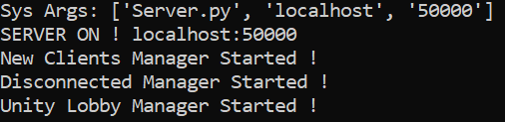

Figure 3.4 Server console log

### 3.4.1 New Clients Manager

This part of the server is running on a separate thread. The server has three main states: unity clients connecting, python clients connecting, game running [3.4.1]. Players are allowed to connect to the server only on the first two states. For a unity client to connect, it is enough to just enter the server details and hit the connect button, the server will do the rest. In case of a python client, the things change a little bit because, this type of client requires a token generated by the server when connecting with unity client that is unique and needs to be set in the python client connection details area. If the server is in the third state, meaning that the game is running, the player will be automatically disconnected by the server, receiving a corresponding message announcing them that they cannot join a game that is currently running.

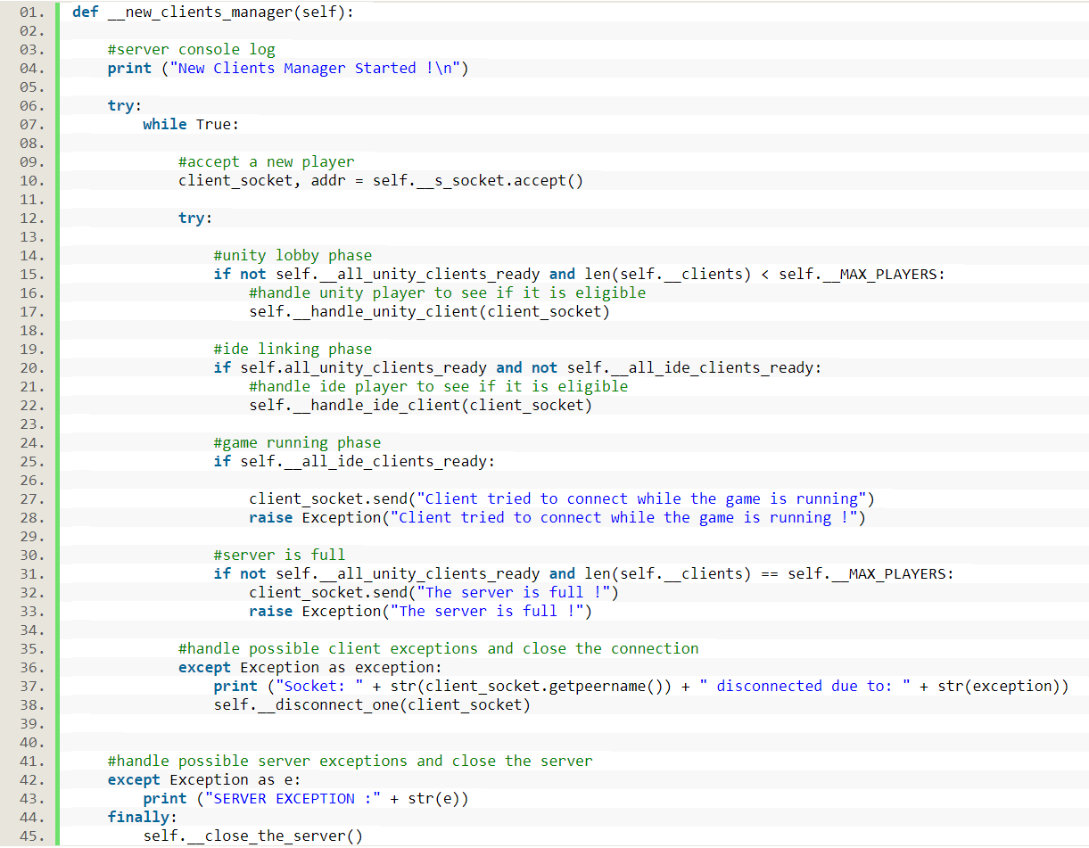

Figure 3.4.1 New clients Manager Method.

### 3.4.2 Connection Handler

This is the place where each client gets in order to be verified by the server. A client handler waits a specific amount of time for the client to send the verification token. The server receives the specific token, verifies it and if it corresponds, the client is added to the players list and is officially connected to the server. If the provided token is wrong or it is not provided in due time, the server closes the connection with that specific player.

**3.4.2.1 Client Class**

The client class is responsible for packing up all the data about a specific user. This class contains a reference to a unity client socket, a python client socket, a user identification token and some information related to the player connection status and states. The class also contains two methods that are running on separate threads, methods used to read data and to write data.

### 3.4.3 Game Manager

This part of the server is running on a separate thread. When the server reaches this point it means that all the necessary unity and python clients are connected to the server and they are ready to play the game. The server creates the initial game data, meaning that it generates the environment data and sends it to each unity client. After this, the game manager waits a period of time and iterates through the list of players to check the response coming from each unity client. If there is no response from a specific player, the server closes the connection with that player. After receiving all the unity clients data, the server forwards it to each corresponding python client to be processed. After the data is processed, each python client sends it back to the server. The server packs all actions received from the python clients and sends it to each unity client to be processed and rendered. This process repeats until the game is over. In case of any timeout from a client, the unity client and the python client are removed from the server.

**3.4.3.1 Disconnect Manager**

As the name suggests, this manager handles the disconnected players. The code is running on a separate thread and it periodically iterates the list of players and checks if a player has disconnected status. If so, it safely closes the connection between the server and that player, removing the user from the list of the players that are on the server.

**3.4.3.2 Game Class**

This class contains all the information about the game. It is specific for the current game, having unique values and functions. This class includes server settings like: the maximum number of players, read buffer size, waiting times for different kind of game states and specific game parameters. Besides this, the game class also packs up the initial data of the game, meaning that it generates the map and formats the data about each player, in order to create the desired playable game environment.

### 3.4.4 Server Build

Using pyinstaller we made a server build [3.4.4]. This bundles a Python application and all its dependencies into a single package The reason for this is to raise the server security by preventing any code modification.

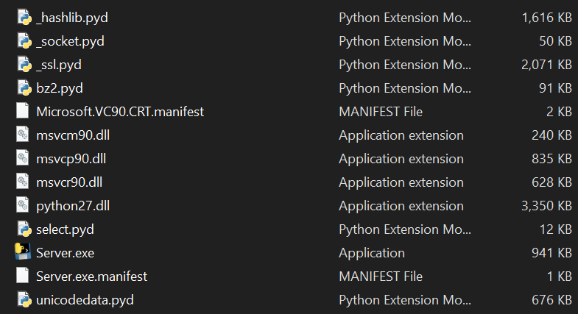

Figure 3.4.4 Server build files

## 3.5 Python client

### 3.5.1 Connecting to the server

To communicate with the server, the Python Client uses a TCP socket. To establish a connection, the user is required to provide the server address, the server port and a client token. The token represents a generated string that is used as an identification code for security reasons when connecting to the server. It is formed of letters and numbers and it is randomly generated. If the user opts for a single player game session, the value of this variable will be “singleplayer”.

A TCP socket is created and the connection is established using the previous server data. If the connection to the specified server address and port fails, the user will get a message.

### 3.5.2 Client validation by the server

After a successful connection to the server, the client token needs to be verified [3.5.2]. As mentioned before, this needs to be done for security purposes. Right after establishing a connection with the server, the client automatically sends the token to be verified. The token reaches the server side and after it gets verified, the player gets a feedback with the server response. If everything went well, the python client remains on the server, otherwise, it gets disconnected.



Figure 3.5.2 Client console log

### 3.5.3 Sending and receiving data

Because of the fact that the game is played using a turn based system, data from the server gets on the client side, it gets processed and then it is sent back to the server. The reading and the writing are separated into two threads. The reading thread waits for the server to send information to the client then it reads and stores this data, on the other side, the writing thread waits for the client to send any data to the server.

### 3.5.4 Player Class

This class represents the editable area of the Python Client. Any user is allowed to modify this class, as it represents the strategy of the game [3.5.4]. The most important part of this class is the solve function. This function contains a list of parameters representing the information about the game at a specific moment. The user has to use this data and to code a strategy in order to get points and win the game. The function is characterized with a return type of string which represents an action that the user would like to perform in the next turn of the game, in order to be closer to win the game. The user may select to perform only one action each round and have to be careful because if the action is not possible it will not be executed by the game.

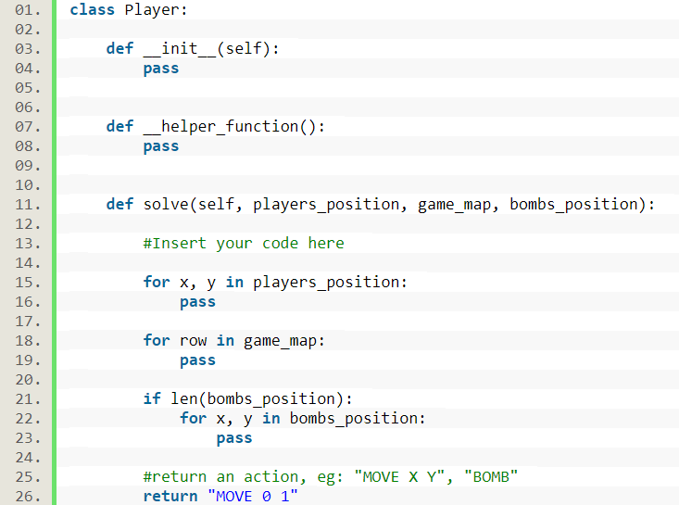

Figure 3.5.4 Player Class

## 3.6 Creating the game

For demonstration purposes we tried to choose a simple game that is already turn based or can be easily played on turns. We came to the conclusion that a Bomber Man like game would be great for the representation. To make the game more interesting, we also added some collectable items that increase the player score. The goal of the game is to collect the most items and to eliminate all other opponents. The game is called Graveyard Friends [3.6] because of the 3D asset it features.

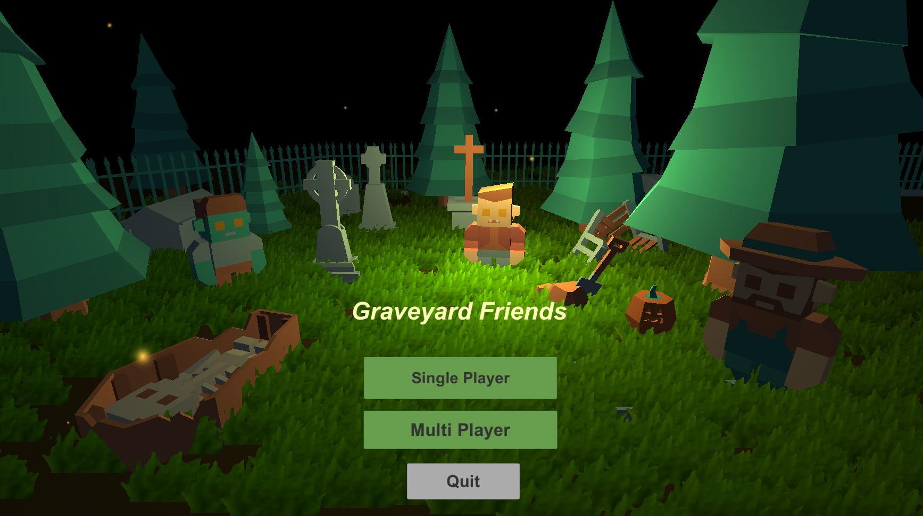

Figure 3.6 Graveyard Friends Game

### 3.6.1 Level design

The level design was made using a 3D asset [3.6.1.1] for the scene environment, unity terrain for generating the grass and unity particles [3.6.1.2] for some effects. The asset is from Kenney.nl site and is called “Graveyard Kit”, being a free to use pack with 3d models.

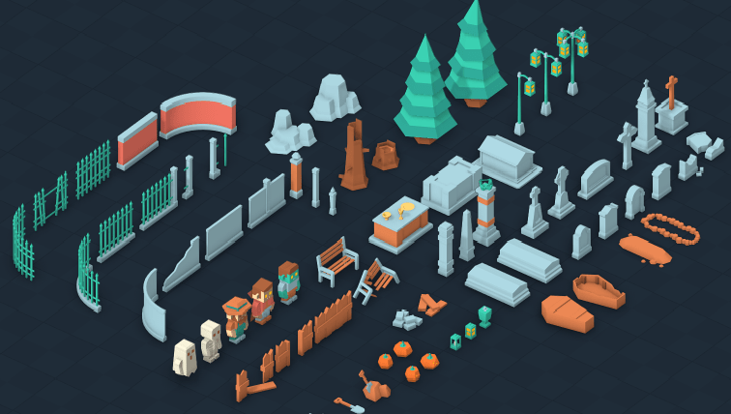

Figure 3.6.1.1 Asset containing the 3D Models

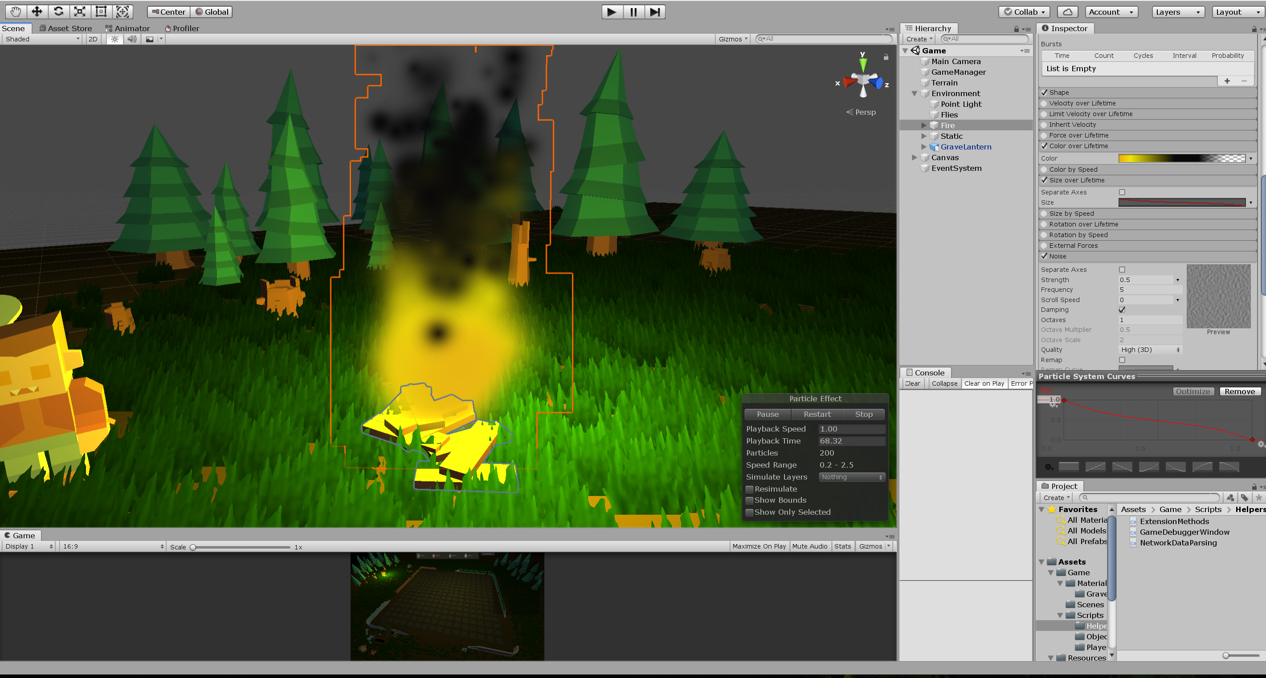

Figure 3.6.1.2 Particles System

### 3.6.2 Map generation

The map generation is commonly used when single player because the user is allowed to choose the way the map will look like. Each map contains players, obstacles and collectables.

Based on some parameters, the map is generated in the following way:

The obstacles are the first to be positioned because the difference between collectables and obstacles is the fact that a player can get through a collectable item but, cannot go through an obstacle. For this reason, it is greatly recommended to start positioning an obstacle that will be surrounded by collectable items than the other way, because the possibility of not placing all the obstacles and creating dead ends is less. When generating the map, because of the fact that the map is a 16x16 square, an object has to be mirrored [3.6.2] in all 4 sides of an xoy coordinate system, considering the center of the map the origin of the system because all the players must have the same difficulty. The players are always placed in the corner of the map.

Besides this, every time an object of type obstacle is placed, a function that uses an iterative form of Depth First Search algorithm check for dead ends. A dead end is formed if an obstacle is placed in such a way that a player cannot move along all the free map spaces.

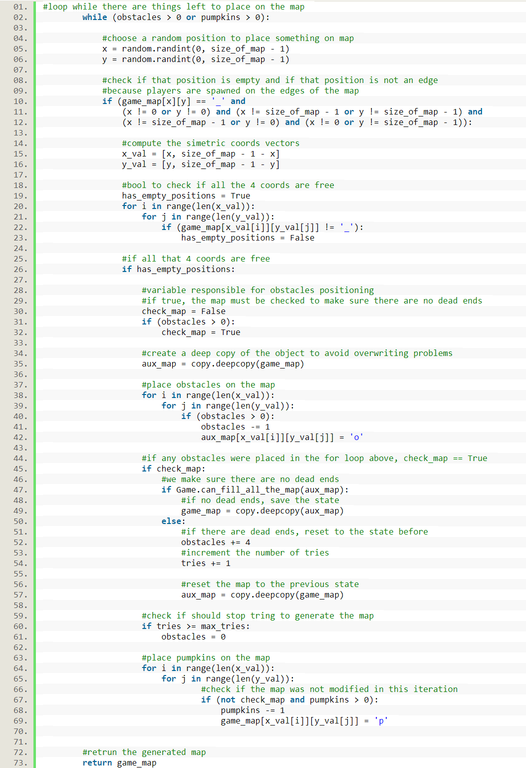

Figure 3.6.2 Map Generation Code

### 3.6.3 Network Manager

The connectivity layer is implemented through the Network Manager class which either creates a Unity server that will be used for LAN single player or establishes a connection with the python server in case of a multi-player session. It is considered a layer due to the fact that it has “DontDestroyOnLoad()” property enable that ensures the fact that when switching from a scene to the other, this object will not be destroyed.

The reading and the writing operations are asynchronous due to the fact that we need the rest of the game to be accessible while sending and receiving data. Each received command is sent to a handler that either modifies the connection state or it modifies the data inside the game manager, this being the game.

An interesting situation occurs when the first game data is sent to the game manager. The current scene does not have a game manager, so we need to load the main game scene in order to access that manager. The process of loading the game scene must be done asynchronous due to the fact that the program must respond meanwhile to other requests.

Furthermore, we have to ensure that the scene is loaded before trying to access the game manager, otherwise this will lead to errors.

If any connection is established, Unity will periodically ping the other end of the connection to see if the it is still available, if no response in due time, Unity will close the existing connection, redirecting the user to the main menu.

**3.6.3.1 Connecting to Server**

To connect to a server, a user has to switch to the Multiplayer scene. There, the user is required to type in the server address followed by the server port and hit the connect button. If the connection to the server succeeds, a button for “ready” response will pop up followed by a corresponding message, otherwise, a connection status message announcing the player that the connection to the server failed is displayed.

**3.6.3.2 Single Player**

It might be weird that a single player session requires a network manager but, here is the reason for that: as mentioned before, to ensure a connectivity between a Unity Client and a Python Client, we need TCP sockets that require a server that handles the data.

When going for a single player session, the Unity automatically creates a localhost server and waits for a player to connect in order to start the game.

**3.6.3.3 Multi-Player**

The multi-player mode is designed for challenging the coding skills with other players around the world. This type of game can be played on Local Area Network (LAN) or on Wide Area Network (WAN).

If the player chooses a multi-player session, after filling up the corresponding fields for the server address and server port, the server will check if a connection might be established on the corresponding information, if so, the network manager will pop up a “ready” button for the player. Pressing that button will mark that the current player is ready to enter the game.

The system was designed this way due to the fact that a lobby cannot rely only on a countdown timer to start the game because players connect and reconnect and also, we cannot start the game only by considering the condition that the lobby has the minimum required players, there has to be the possibility to send any number of players to the game whenever they want, basically, whenever they are ready.

### 3.6.4 Initial Game Data

Right after the moment when all the players are connected to the server and the game is ready to start, there is no playable map. The idea is that, for security reasons the map has to be generated on the server and sent to each Unity Client. This is called the initial game data, the block of data that is responsible for creating the same environment for each user, containing the info about the generated map and the players that will play in that session. Each packet of information received from the server needs to be decoded and interpreted.

Besides the initial game data that is sent only once, a packet of data contains commands that are separated by new line. A command represents a mapping of form: key: <token> and the value: <action>, which will further be interpreted by the Game Manager of the Unity Client as: The player with <token> is willing to perform <action>.

### 3.6.5 Game Manager

The Game Manager is the brain of the game. All the information received from the server gets processed inside the game manager which keeps track of any object of the scene. This manager is specific designed for the current game.

**3.6.5.1 Game preparation**

This is the first part of the Game Manager that will be executed in order to run a game session. For both single and multi-player, there are some things that need to be prepared before a game can start [3.6.5.1]. Considering the single player, the game manager will generate the corresponding map and will fill the player slots with AIs. If the game is a multi-player one, the game manager will fill the map considering the data received from the server and will position the players accordingly [3.6.5.2].

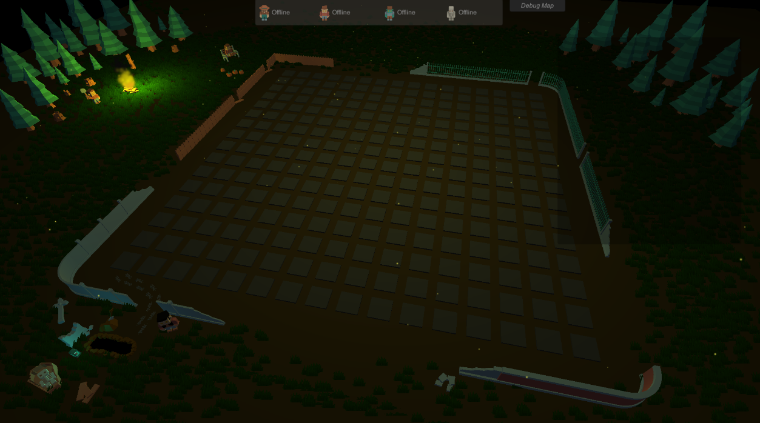

Figure 3.6.5.1 Map before preparation

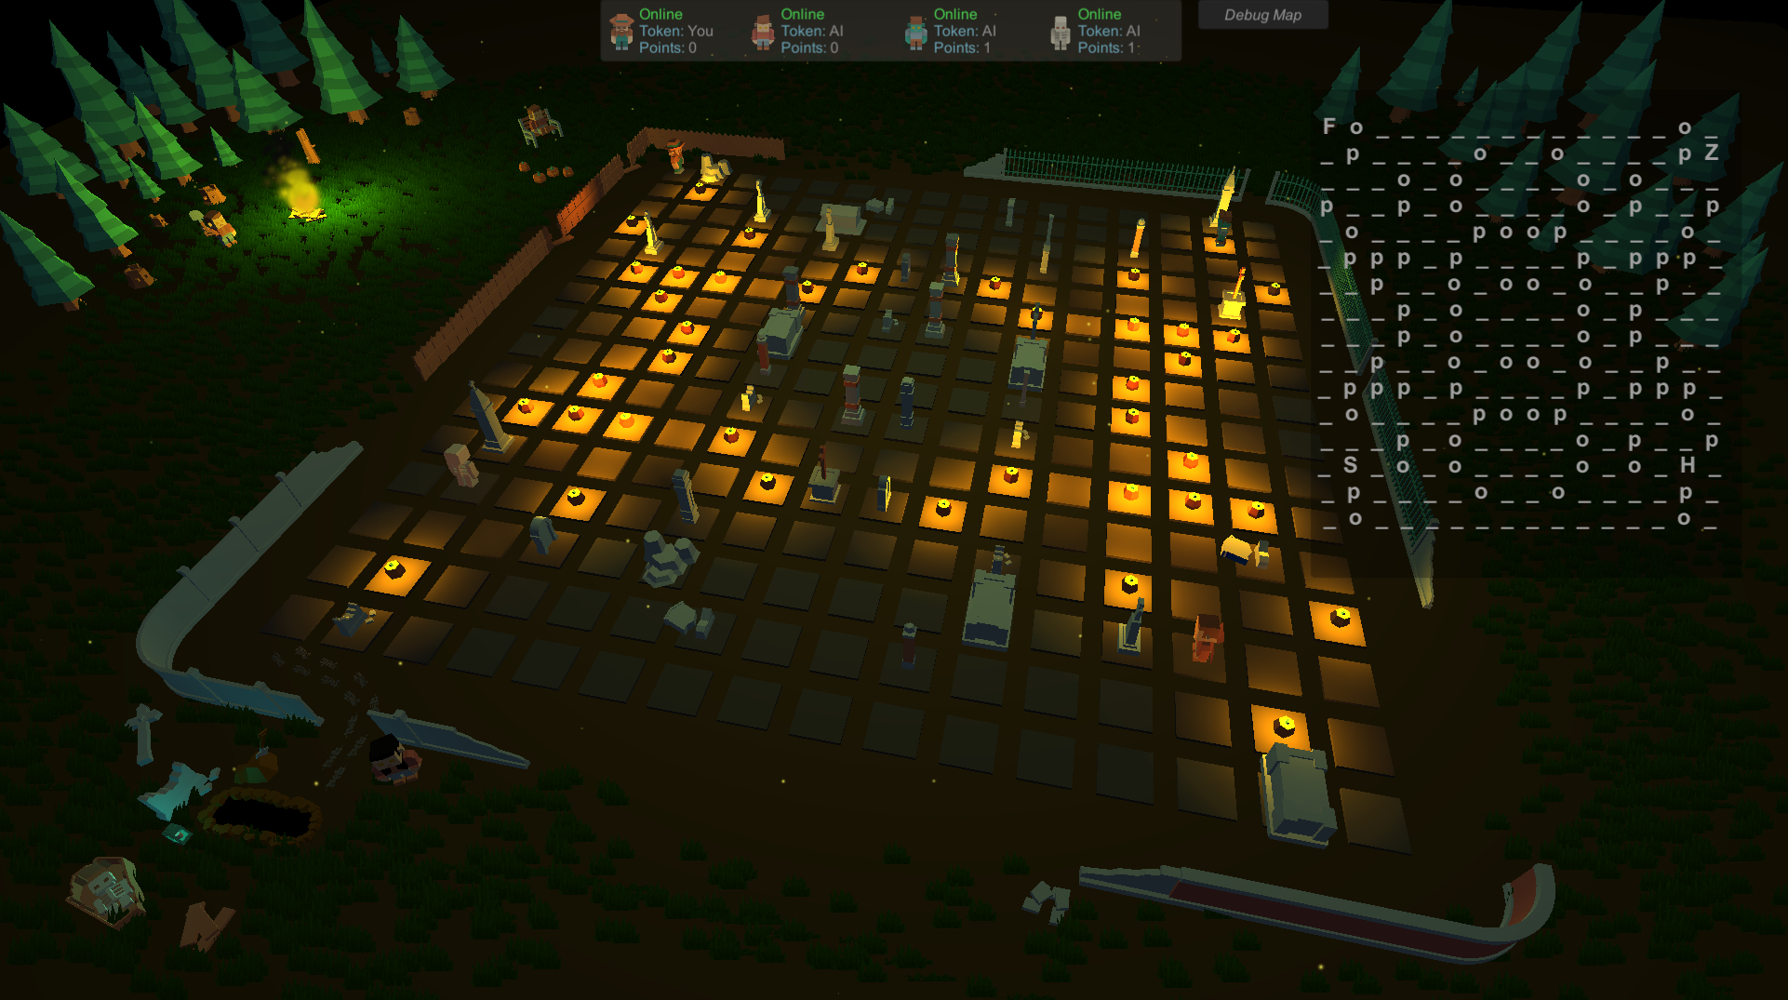

Figure 3.6.5.2 Map after preparation

**3.6.5.2 Single Player Mode**

Because of the fact that this is a challenge based coding platform, there is no need to always have an internet connection hence the user may opt for single player sessions. The benefits of this mode are the following: there is no wait time for the other players, the strategy is easier to test because the user is allowed to change the map parameters [3.6.5] and last but not the least, there are AIs to play with. AI (Artificial Intelligence) Player represents a non-human type of player that already has a predefined strategy. The AI has a standard strategy, just for demonstration purposes.

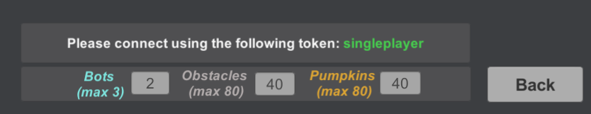

Figure 3.6.5 Single player parameters panel

**3.6.5.3 Managing the Data**

Each map contains players, obstacles, collectable items and bombs. Considering all of these, a representation of the map might be represented as char matrix is not enough. There are some edge cases: 2 or more players might sit in the same place, a bomb might be placed right under the player and this representation of the map is not enough to recognize these cases. The solution would be to use lists for objects that may overlap.

**3.6.5.4 Process One Round**

On each turn, the Unity Client gets data from the server about each player. This data represents commands that are going to be executed. To process one round, we need to handle different kind of things in a specific order. At the beginning, the Game Manager will check if there are any bombs active on the map and will update their timer or detonate them because, otherwise, a player may exit the bomb area and this would have no effect, even though it should, leading to a bug. Next, each players command is sent to a handler that will execute it. The handler checks if the player is able to perform that specific action and if so, it gets executed, otherwise, nothing happens. The available actions are: MOVE X Y, BOMB.

At the end of the round, the players that are sitting on a position containing a collectable item, will receive that item.

**3.6.5.5 Get Session Data**

Each round the server sends data to the Unity Client that is processed locally by each game. Each Unity session needs to send updated game info back to the server. In order to do this, all the data needs to be packed in a specific manner. We will pack up player data. If the current player is not able to play anymore due to the game rules, Unity will send back the following data “SPECTATE” announcing the server and the python client that the player is not able to perform any further actions. If the player is able to play, we first pack up all the player positions starting with the current player then pack up all the map data, followed by the position of the active bombs on the map, if any.

### 3.6.6 Map Debugger

Map debugger is a tool that helps a user to see what is going on the map [3.6.6]. This is a separate game panel that might be turned on and off and it consist of a matrix of chars that represents the map. This is very helpful for the users when debugging the code and also a good way to immediately see what is going on the map.

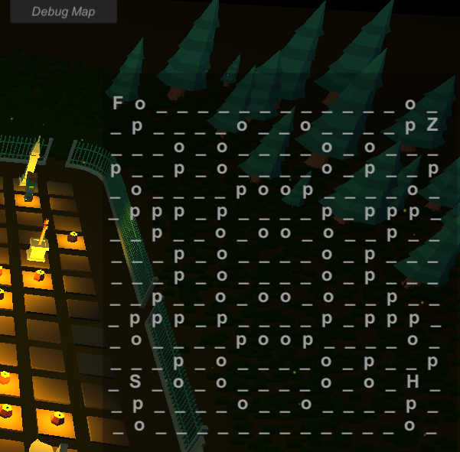

Figure 3.6.6 Map debugger

## 3.7 Platform Strong Points

* The games can be played with no internet connection
* The response time is instant, apart from the web platforms where thousands of users are connected together, this platform relies only on the speed of the connected players, which in our case can be a maximum of 4.
* Easy hosting of the server on the internet because it supports command line parameters and also comes in two forms: executable and source code
* The system is built in such a way that adding a new game is simple, besides the information about the game, all the classes are generic. There is nothing more to modify except for the Game Manager class and the game rules for the python server and client.
* Customizable map while playing single player.
* Map debugger for an easier implementation of the strategy.
* User friendly interface and easy to use program.

**Chapter 4**

# Results and discussions

**Chapter 5**

# Conclusion

**Chapter 6**

# Future work

Unity Game

* Add unity player the possibility to create a server from the game.
* Add more games to the platform.
* Improve the strategy of the AI and create a league system for the players.
* Create a match finder scene where the players would be able to access random games all over the world.
* Create a debugging system inside the single player game, allowing the player to pause the game.
* Adding more details about the current game like: the last executed command, current command, a dashboard with the current winner.
* Add sound system for a better game feedback.
* Character builder. Allow players to create their own character.
* Messages system. Allow players to send messages using their character.
* Creating a build for Web, Android, iOS.
* Create the possibility to write code inside the Unity Game.

Server

* Reduce the data traffic in order to be able to host the server on an internet domain.

Client

* Add some helper functions for the player and more instructions.
* Add support for different coding languages.

# Bibliography

[1] Teodora Bakardjieva. Introduction to Computer Networking https://www.vfu.bg/en/e-Learning/Computer-Networks--Introduction_Computer_Networking.pdf

[2] Techopedia. Data packet <https://www.techopedia.com/definition/6751/data-packet>

[3] Computer networks and data communication <https://peda.net/kenya/ass/subjects2/computer-studies/form-4/itcn>

[4] [Vangie Beal](https://www.webopedia.com/author/Vangie-Beal). Network and communication <https://www.webopedia.com/TERM/N/network.html>

[5] Techopedia. Network Address

<https://www.techopedia.com/definition/20969/network-address>

[6] [Vivek Shah](https://medium.com/@vivekshah.P?source=post_page-----705898a2a04----------------------). Reasons why unity3d is so much popular in the gaming industry. <https://medium.com/@vivekshah.P/reasons-why-unity3d-is-so-much-popular-in-the-gaming-industry-705898a2a04>

[7] Tutorialspoint. What is a socket. <https://www.tutorialspoint.com/unix_sockets/what_is_socket.htm>

[8] Andrew T. CampbellDartmouth. Socket Programming <https://www.cs.dartmouth.edu/~campbell/cs60/socketprogramming.html>

[9] Computer Networking. Client-Server Network <https://computrnetworking.wordpress.com/2012/02/20/client-server-network/>

[10] David M. Beazley. Python Network Programming. <http://www.dabeaz.com/python/PythonNetBinder.pdf>

[11] Socket Programming in Python <http://www.biogem.org/downloads/notes/Socket%20Programming%20in%20Python.pdf>

[12] Brandon Rhodes and John Goerzen. Foundations of Python Network Programming <http://index-of.es/Varios-2/Python%20Network%20Engineering.pdf>

[13] Unity. The world’s leading real-time creation platform. <https://store.unity.com/download-nuo>

[14] Kenney Assets. <https://kenney.nl/assets/graveyard-kit>

[15] Python 2.7 <https://www.python.org/download/releases/2.7/>

[16] Unity Manual. Offline documentation. <https://docs.unity3d.com/Manual/OfflineDocumentation.html>

[17] Jeff W. Murray. C# Game Programming Cookbook for Unity 3d <http://netsites.mx/Unity3dTutorials/C%23GameProgramming.pdf>

[18] Mike Geig. Unity Game Development in 24 hours. <http://docshare02.docshare.tips/files/28607/286070481.pdf>

[19] Tutorialspoint. Python Multithread Programming. <https://www.tutorialspoint.com/python/python_multithreading.htm>

[20] Joona Raappana. Great Particles and How to Make Them <https://www.theseus.fi/bitstream/handle/10024/156135/Raappana_Joona.pdf?sequence=1&isAllowed=y>

[21] Alan Thorn. Unity 5.x by example.

<https://www.pdfdrive.com/c-scripting-in-unity-e43056290.html>

[22] [Nathan Jennings](https://realpython.com/python-sockets/#author). Real Python. Python Sockets. <https://realpython.com/python-sockets/>

[23] Digital Pedagogy - A Guide for Librarians, Faculty, and Students

University of Toronto Libraries. https://guides.library.utoronto.ca/c.php?g=448614&p=3505475

[24] Victor Samuel Zirawaga, Adeleye Idowu Olusanya, Tinovimbanashe Maduku. Gaming in Education: Using Games as a Support Tool to Teach History <https://files.eric.ed.gov/fulltext/EJ1143830.pdf>

[25] [Pandey U.S. & Shukla Saurabh](https://www.google.ro/search?hl=ro&tbo=p&tbm=bks&q=inauthor:%22Pandey+U.S.+%26+Shukla+Saurabh%22) E-Commerce and Mobile Commerce Technologies. S. Chand Publishing, 2007 https://books.google.ro/books?id=N-6hDwAAQBAJ&